

Computer Science 301

**Web Technologies**

**Practical 3: Week beginning 19 October 2020 [60 Marks]**

1. Create the following table with all the formatting. You are required to do the following:

As discussed in class, JavaScript comes with various predefined classes, the Date class being one of them. When we create a Date object, the object will get the current date and time information that contains every detail of a date from the system. The information that a date object might contain is similar to the following:

**"Tue Oct 20 2020 13:58:27 GMT+0200 (South Africa Standard Time)"**

There are various getter methods to retrieve the different parts of the date, like Hours, Minutes and Seconds. The year is referred to as FullYear in the date object, so is its getter method. You can use the console in the developer tool to find more about the methods.

***Instructions***

1. Write an HTML document that contains a JavaScript program that will produce the content shown in the following picture when the page is loaded. You should define appropriate variables to hold the different values. Basically, you are expected to use the document.write method to create the different content of the HTML document by including the appropriate HTML tags as shown in the page below.

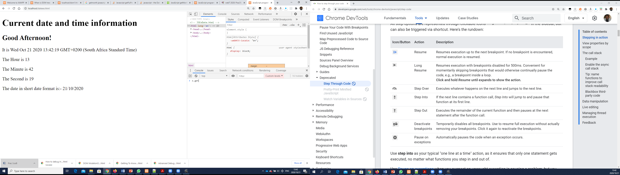

1. The phrase “Current date and time information” is contained in an H1 tag.
2. The phrase in the second line (“Good Afternoon” in the above picture) varies depending on the time of the day. If the hour is less 12 then that line should display “Good Morning!” else it should display “Good Afternoon!” as shown above.
3. The content in all the other lines are contained within a P tag.
4. The numbers, like 14, 57 etc come from the data object.
5. Concatenate the specified phrases in each line with the values from the data object to create similar page.
6. In this question, you will create JavaScript prevalidation for the form you used in Prac2 (shown in the diagram below – the HTML file (formprevalidation.html) is also included in the resource folder).



***Instructions***

1. You will need to link the document to an external JavaScript file in the head of the page so that you can write code in its own file. Name the javascript file formvalidator.js.
2. You should define a CSS style to use to highlight a blank field (as shown in the diagram above).
3. Set up a listener on the form’s submit event so that the code prevents submission of the form (by calling preventDefault()) if either the title or description field is left blank or the accept license box is not checked, but otherwise submits the form. (Hint: you can use querySelectorAll (with the appropriate information) to select various similar items)
4. Enhance the JavaScript so that blank fields trigger a change in the appearance of the form (using the style defined earlier).
5. Add another listener to the fields so that when the user types into a field (changed event) Javacript removes the red color you just added.
6. Open prac3Q3.html file from the resource folder and do the following:
7. Format the Div so that it has a grey border color.
8. Position the div in the center of the page taking 60% of the view width and border 3px solid line. It has to stay at the center even when you resize the window (Hint: you can set left and right margins to auto)
9. Everything inside the Div has to also be centered (Hint: setting the table to be inline-block will help you to set everything center with one setting).
10. include a JavaScript code to achieve the following:

Add an EventListener to the “Calculate Average” button that will trigger the calculate function when the button is clicked. The function will then calculate the average exam result and put the result in the last cell of the table as shown below. (Hint: A Table object has rows property that returns an array of rows in the table and the cells property of a row object returns an array of cells in the row). Also include a code to enter the phrase Well done! (as shown below) below the button. (Hint: you need to create an element and append it to the Div.)

